Newsletter September 2023
It’s been a whole year since the last one – too busy dancing to write it!

I do hope all our families had a wonderful summer break, and that everyone is enjoying their return to dancing. The teachers at HSD have loved seeing everyone again and catching up on all the news!

WELCOME!
As always at the start of a new academic year we wish a warm welcome to all our new starters. It’s always so nice to see some fresh faces and have new families join us at HSD. Do feel free to drop us a message if there’s anything you’re unsure of, or ask other parents – they’re a friendly lot - I can personally vouch for that!

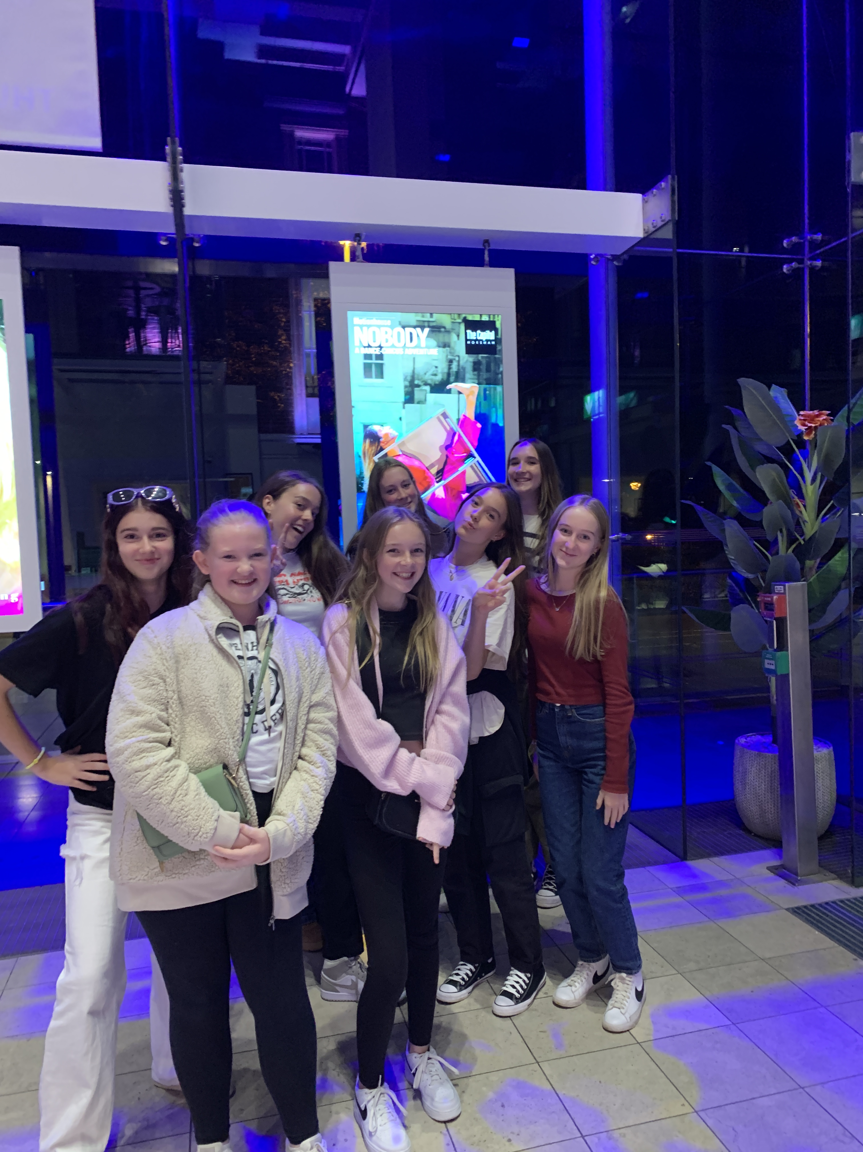
HSD SCHOOL OUTING – SEPTEMBER 22
Term got underway quietly after all the excitement of our hugely successful shows at the Capitol Theatre in the Summer.
A group of students went back to the Capitol to see ‘Motionhouse’ – a brilliantly physical and energetic dance company who were performing their show ‘Nobody’. Motionhouse are back at the Capitol again this October half term with a show suitable for younger audiences. I’d highly recommend it for all dance fans!

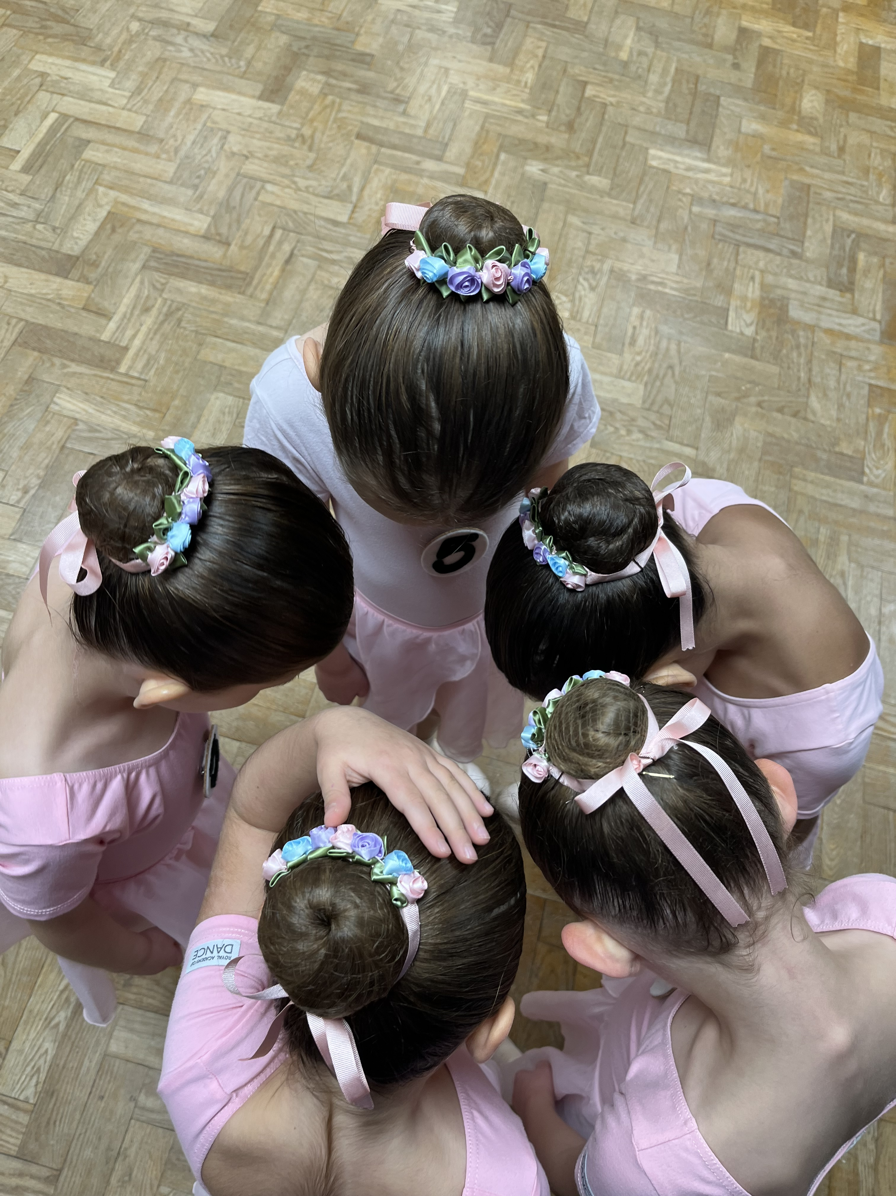
EXAMS
Over the course of the year, we held several exam sessions in RAD ballet and ISTD tap and modern. Students from ages 4 up to 18 took part and every one of them excelled! Exams and Class Awards are a fantastic way to mark our students’ progress and for them to have their achievements recognised by visiting examiners. Well done to everyone who took part this year.

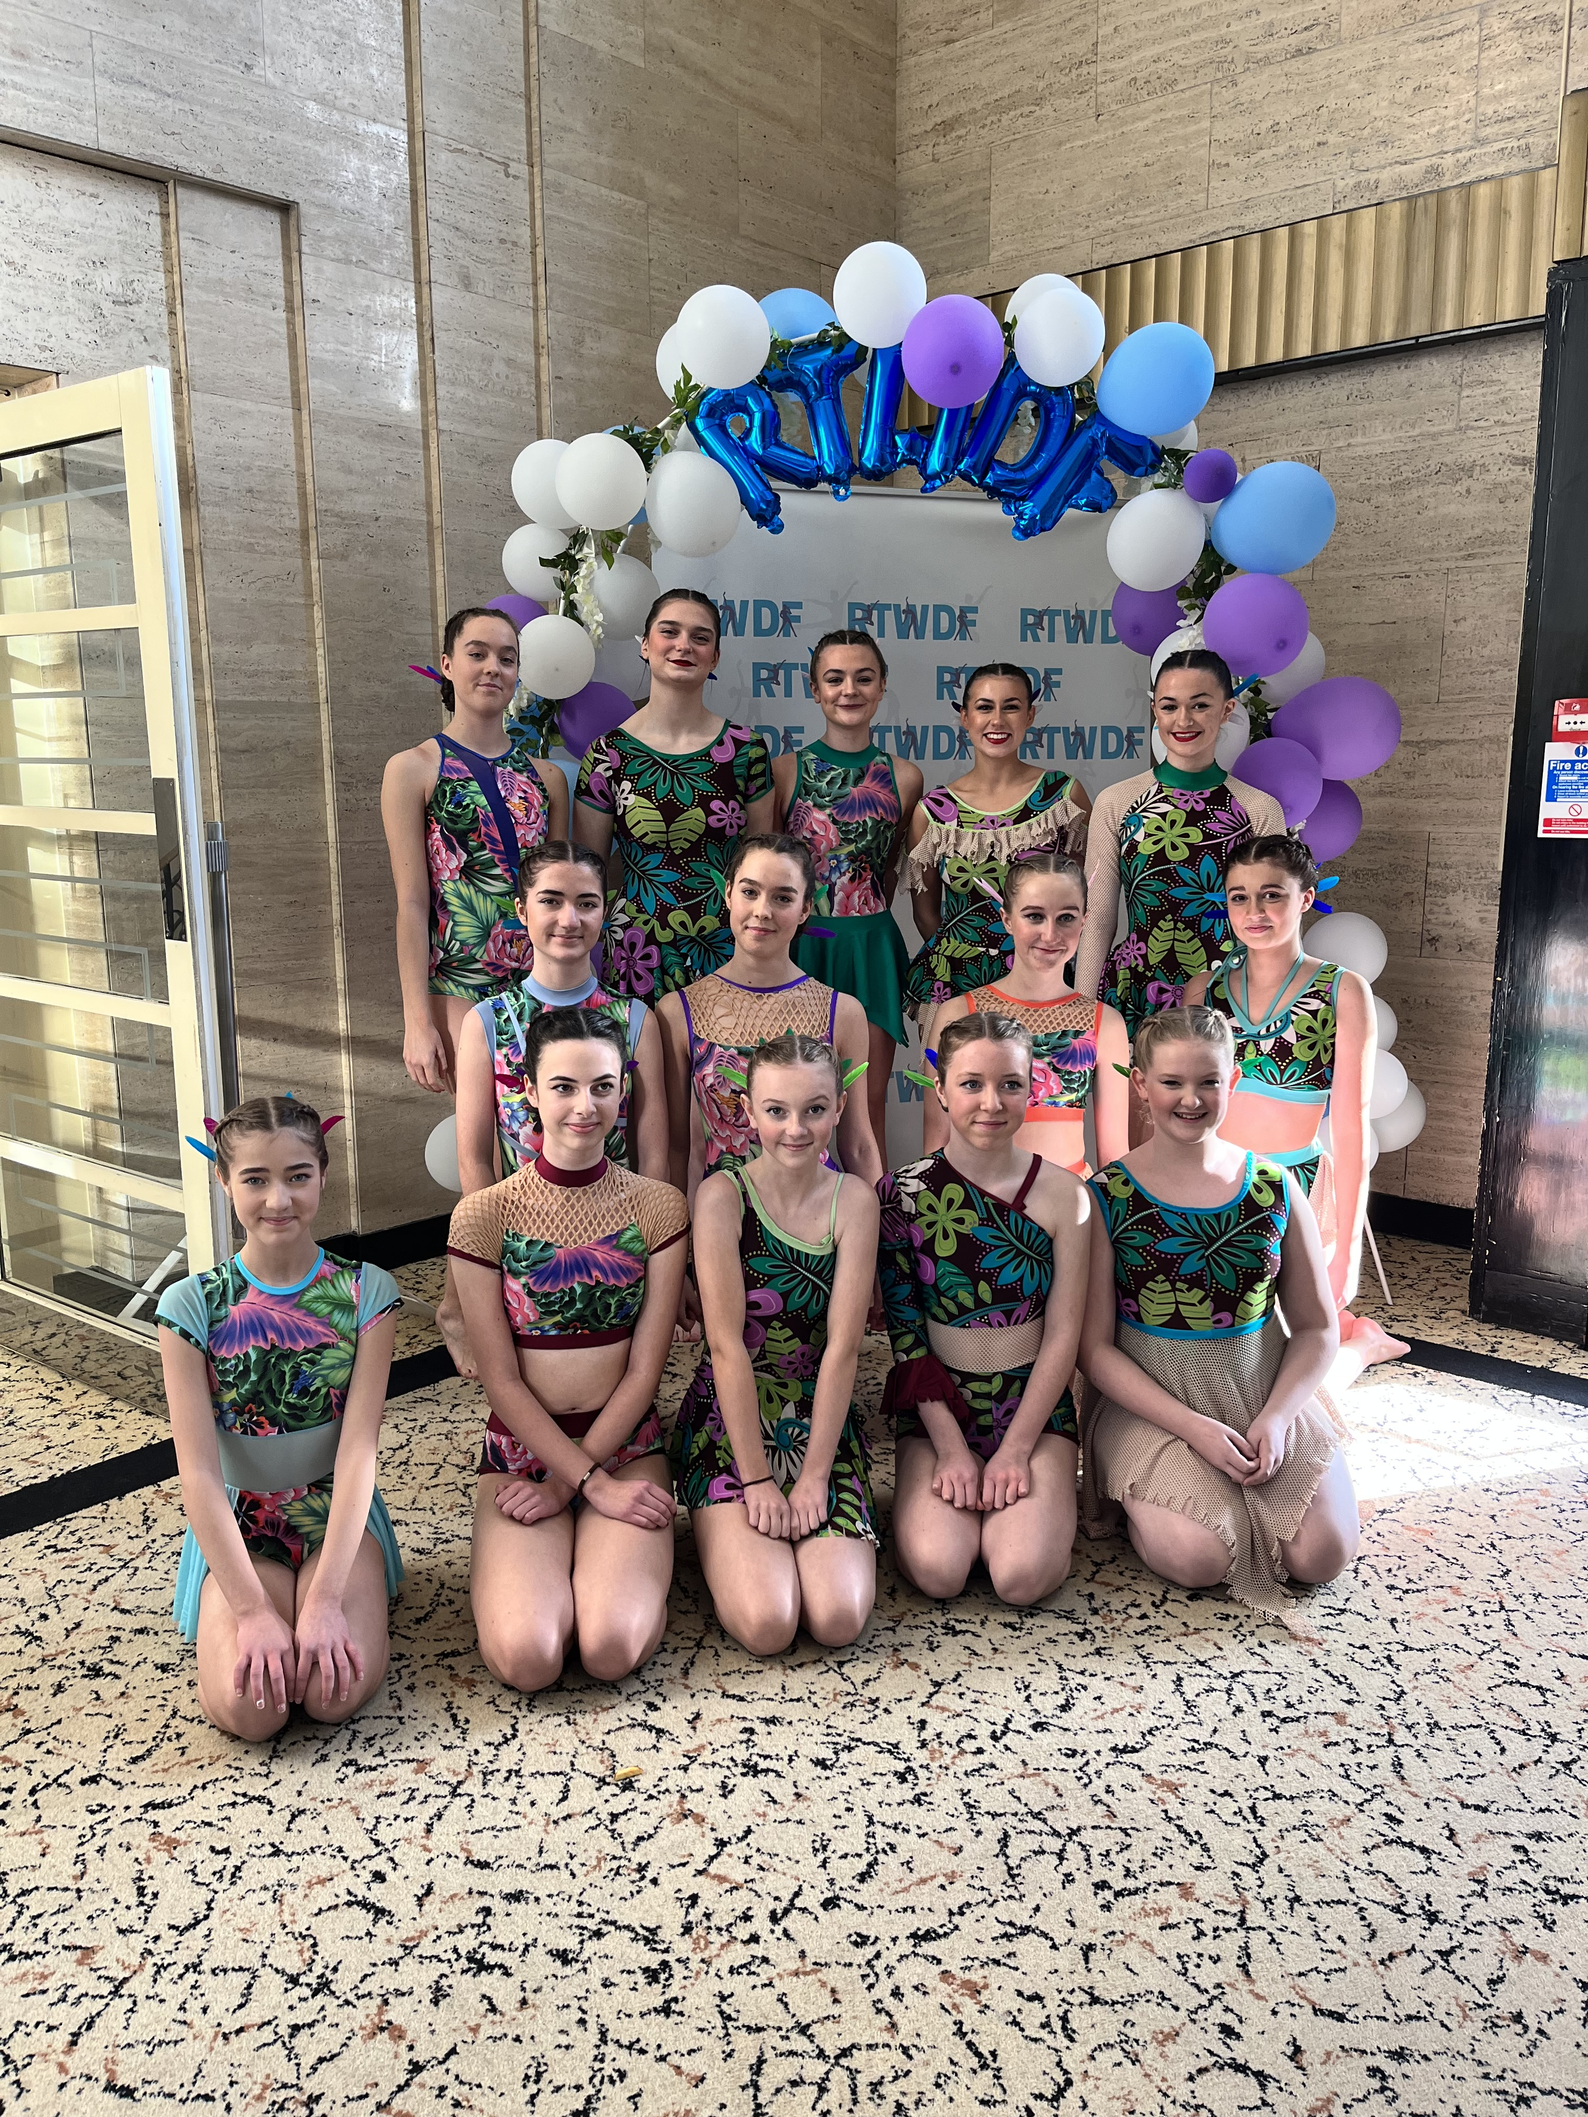
FESTIVALS
For the first time last year we entered a group into Festivals, as well as continuing with our solo and duet dances. Our newly formed HSD Company went to three competitions during the Spring and Summer terms - they grew in confidence and improved on their mark each time. This year we have two dances to take out, and I have high hopes that we’ll be able to announce some great results soon! Our solos and duets continued to impress adjudicators with Abbie Judd being nominated for a Bursary award at East Grinstead Festival in May.

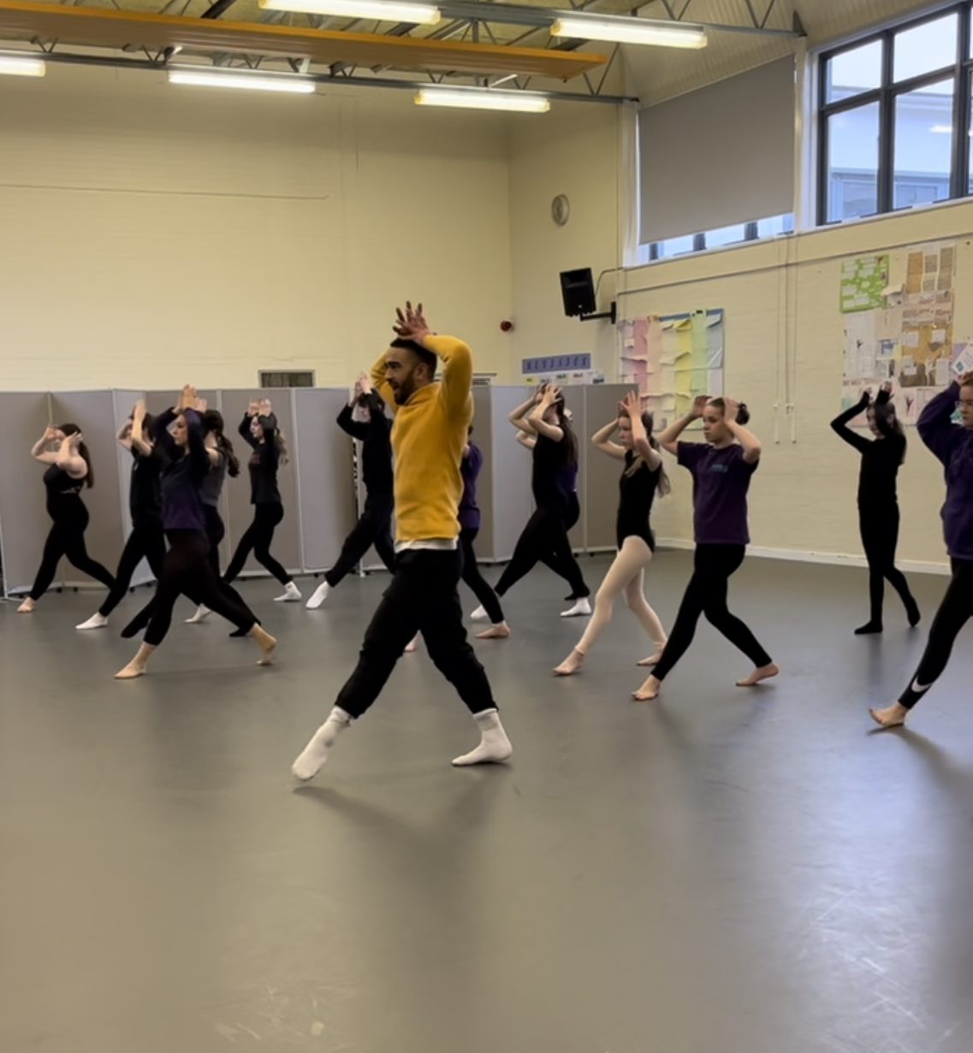
WORKSHOPS
We were so lucky to have professional dancer Lukas Hunt come to lead some workshops for us in January. Lukas has danced in many productions and came to teach our students dances inspired by his time in The Lion King. He also led our older students through a pirouette and turns technique class. They loved his energy and wisdom and hopefully we’ll be able to get Lukas back sometime soon when he’s not too busy on stage!

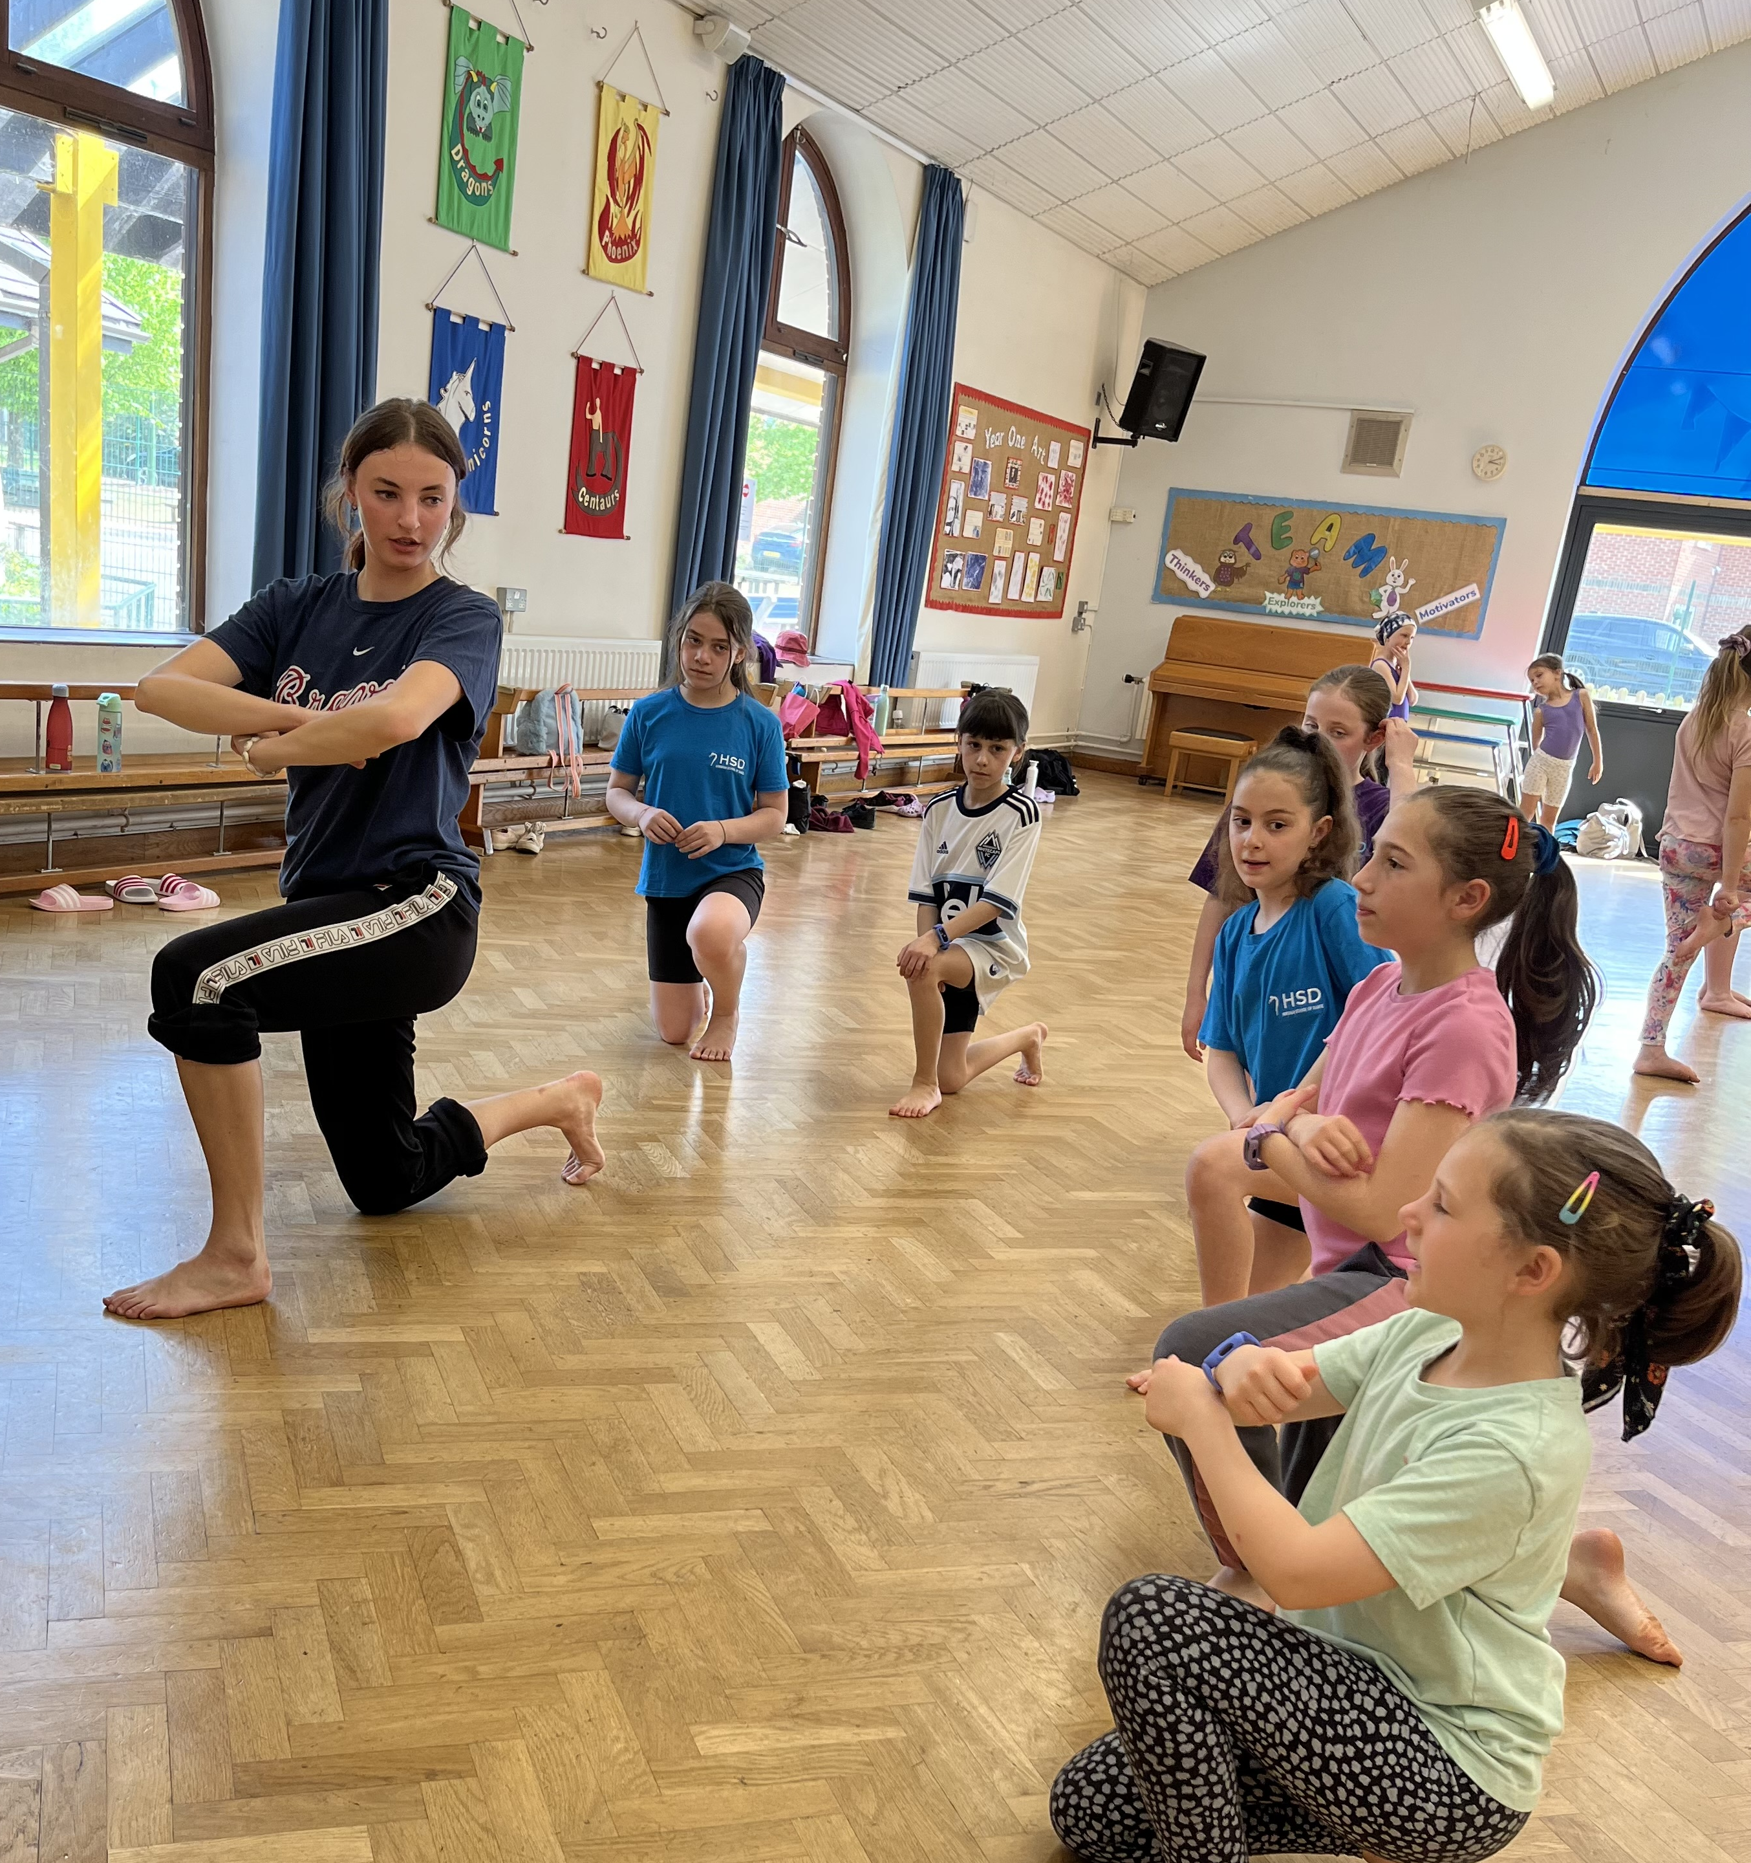
CHOREOGRAPHY WORKSHOPS and SHOWCASE
We also had two of our former students, Georgia Howlett and Catherine Sleeman, come to lead some creative workshops for us. This was a pre-cursor to holding a choreographic showcase, and their aim was to inspire and enable students to create their own dance. At the showcase we saw some brilliant work, in so many styles, and it was so lovely to see them being able to express their own ideas through dance.

STUDENT SUCCESS
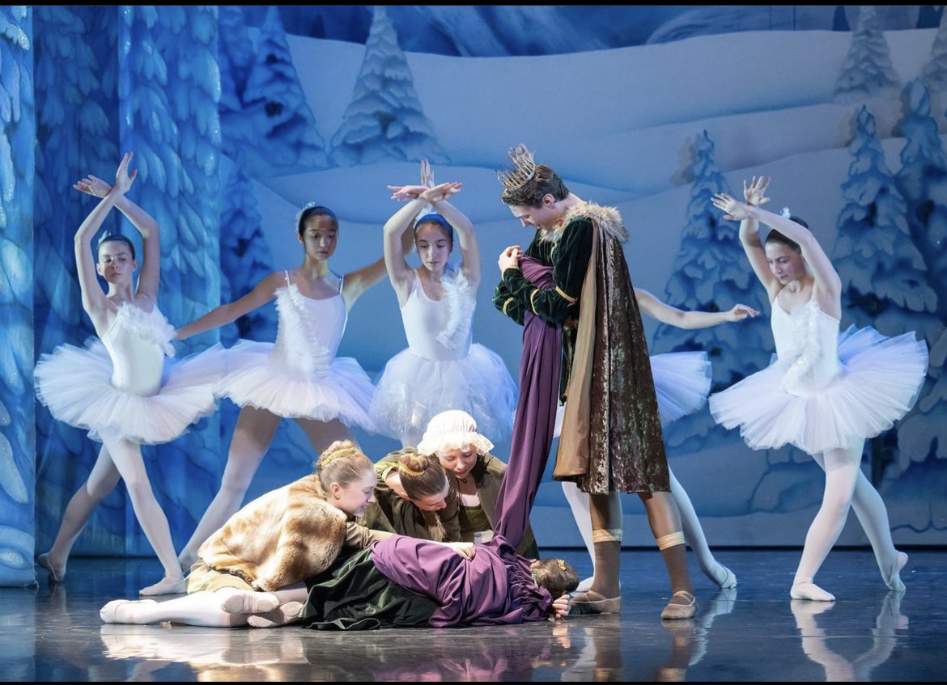
In April, Taylor Ticehurst performed the role of the King in London Children’s Ballet production of Snow White at the Peacock Theatre. This was one of many achievements for Taylor in the year, where he also was accepted onto the Royal Ballet School’s Summer Intensive and Senior Associate Programmes, as well as being offered a full scholarship to Tring Park Performing Arts school, where he has now begun full time training.
Continuing our theme of successful boys, Alfie Milborrow and Liam Watts are both now training at Brit School – Alfie on the dance strand and Liam doing Musical Theatre. He follows in the footsteps of Abbie Judd, who having completed her time at Brit, is now at Urdang – one of the UK’s leading performing arts Universities. Amelia Edson has begun full time training at the prestigious Elmhurst Ballet School and Kitty Cornish starts at Chichester University on their Dance Performance BA course. Holly Whitefield has once again been chosen to perform with this year’s English Youth Ballet’s production. She’ll be appearing at the Hawth in November in Coppelia so we’ll be organising a group trip. We love to hear about our students’ many achievements in dance and theatre. Please let us know about them so we can include them in future newsletters.

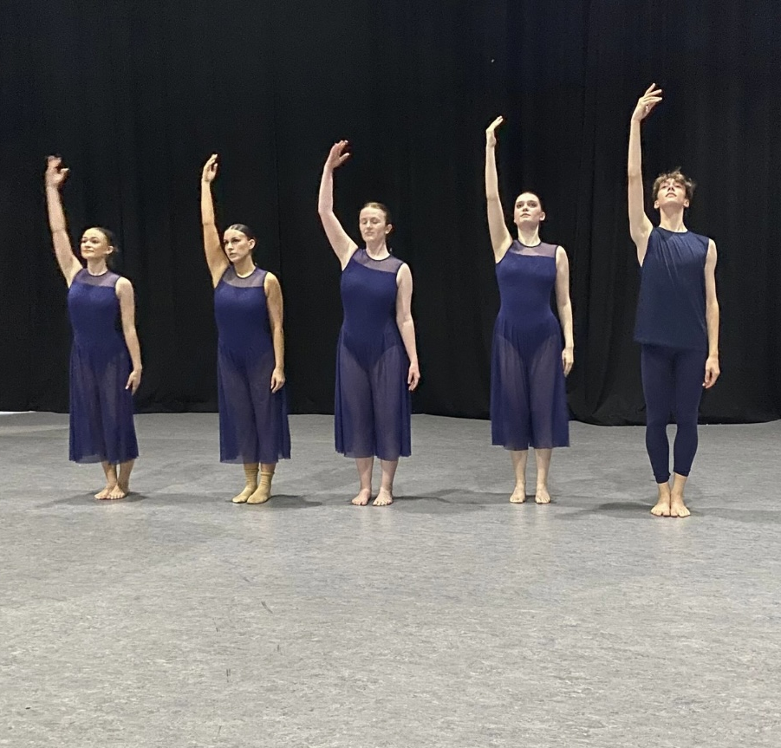
LEAVERS SHOWCASE
To celebrate our students who were ‘graduating’ from HSD, we held a showcase in their honour. They each performed a solo in a dance genre of their choice, along with dances from our most senior classes. Not all our leavers want to go into dance as a career of course, and this was our chance to wish them well in their futures, knowing that wherever life takes them, they’ll not only take with them a love of dance, but also lifelong friendships made during their time here with us.
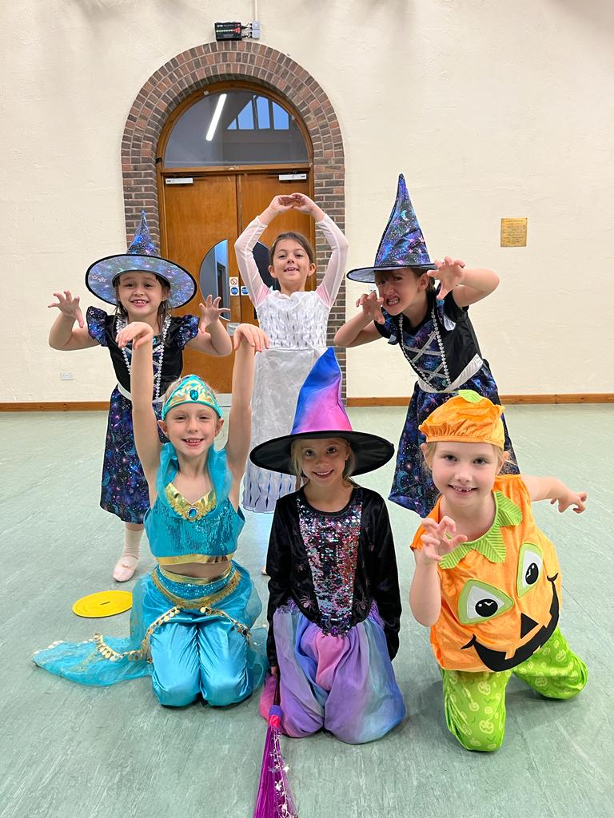
DATES FOR YOUR DIARY
Dressing up week – 16th-21st October
A regular slot in our calendar now! Students may dress up for classes – anything goes (so long as they can dance in it!) and we give a prize for the most creative ‘dance’ themed outfit! There’s a suggested donation of £1 to enter and we’ll choose a charity to donate to. Suggestions of local charities are always welcome.

Christmas Showcase – 10th December 4.30-6.30pm at Tanbridge House School
This involves all classes from all genres showing a short section of their classwork – hopefully an inspiration to the younger ones to see where they’re headed, as well as an opportunity to bring families together for a mince pie or two!

HSD Shows (Main and Mini) – 13th-14th July 2024 at The Capitol Theatre
I can hardly believe this has come round again so quickly! The shows at HSD are an absolute highlight of our calendar and next year we will be doing our version of Peter Pan! As well as the dates of the actual shows above, the 29th June, 6th July and Friday 12th July (after school) will also be essential dates for your diary for the final dress and technical rehearsals. We pride ourselves on the professional nature of our shows, and it takes commitment from everyone to make them as fantastic as they are! Preparations will begin in earnest from around February next year, and before then you will receive lots more information, but in the meantime do please ask the teachers, Katey or myself if you have any questions about what the shows involve.

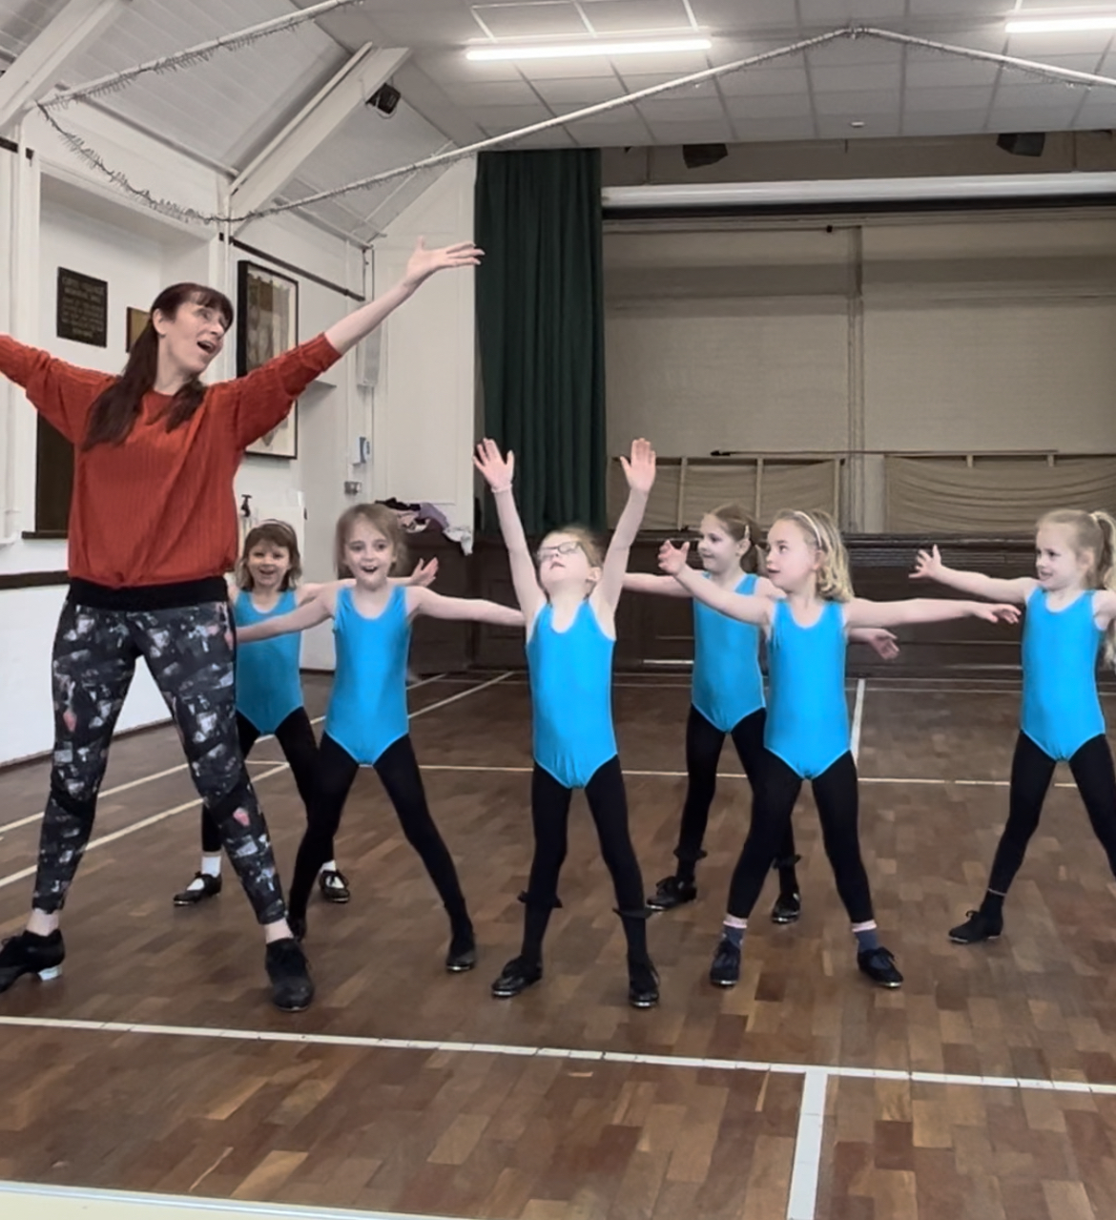
NEW CLASS
We’ve added a new beginners Tap and Modern class to the timetable, as the Saturday classes are so full now! It’s on Wednesdays with Miss Michaela at 4.30-5.15 at North Heath Hall. If we have any younger ballet students (5-7ish years old) who would like to try Tap and Modern dance, then please do get in touch. You can ‘try before you buy’ so why not bring a friend along and have a go! No tap shoes necessary for your trial class

DANCE SHOW TRIPS
Recommendations for dance performances that are coming to a venue near us soon:
As mentioned above ‘Motionhouse’ bring their latest work ‘Starchitects’ to the Capitol Theatre on October 26th. Their dance-circus style is an exciting watch, and this show is aimed at family audiences.
https://www.thecapitolhorsham.com/whats-on/all-shows/starchitects-by-motionhouse/21381
Don Quixote by the Royal Ballet will be shown as part of their cinema season at the Everyman on Tuesday November 7th. These live streamed performances from the Royal Opera House are always a great way to see world class ballet.
https://www.everymancinema.com/film-listing/308749-roh-live-don-quixote-20232024-ballet/

WEBSITE AND SOCIAL MEDIA
Our website has information for parents such as the timetable, uniform lists, safeguarding and school policies etc. You’ll need to go to the ‘Parents area’ tab and enter the password HSD5678

We use social media for regular updates on events and news at HSD:
https://www.horshamschoolofdance.co.uk/parents-area
Find us on Facebook – we have a public page https://www.facebook.com/HorshamSDance
Plus a closed groups for parents
https://www.facebook.com/groups/502600303140650
We’re also on Instagram
https://www.instagram.com/horshamschoolofdance/
If you are regularly on Facebook, please do recommend us if you see people looking for dance classes.

Here’s to another amazing term at HSD!

Miss Annie

